Dakar BRT
Program Area: Developing High-Quality, Low-Cost Mass Transit
Country: Senegal
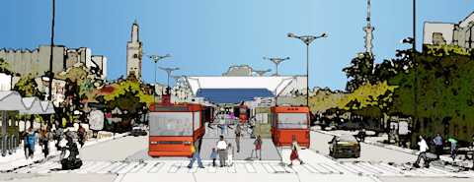
Général De Gaulle BRT Station rendering (Source: Luc Nadal, ITDP)
Dakar, Senegal, like many cities around the world, faces an increasingly intractable transportation crisis. The motor vehicle fleet in Dakar is growing at over 8% per year. Though only 10% of the population in Dakar owns a car, this small, wealthier group consumes the vast majority of the city’s scarce road space while the 76% of the population that uses some form of mass transit faces worsening traffic congestion.
Each year, hundreds of thousands of hours of economic productivity are lost and cases of severe respiratory illness increase steadily. The only solution to Dakar’s unsustainable situation is to get more people out of their private cars and onto higher quality public transportation systems. The city’s density is very high in comparison to other African cities and is one of the best suited to the middle-range mass transit options that bus rapid transit systems offer.
ITDP has played a key role in laying the groundwork for a BRT system in Dakar. Beginning in 2003, ITDP organized a number of technical exchanges between Dakar decision-makers and counterparts from cities abroad with valuable sustainable transport experience to share.
ITDP sent Enrique Peñalosa, the former Mayor of Bogotá, Colombia and other experts to Dakar to hold workshops as part of the “Building a New City” tour. City- and national-level officials expressed great interest in replicating many of Bogotá’s experiences, including its state-of-the-art BRT system, TransMilenio.
ITDP secured a grant from the Global Environmental Facility (GEF) that funded a preliminary BRT study for Dakar. The city’s Master Plan now identifies a bus rapid transit system as one of its key elements and Dakar is under serious consideration by the GEF to receive funding for a comprehensive BRT plan.
Questions about this project can be directed to:
Aimée Gauthier
agauthier@itdp.org

